Unit II: Data Collection and Pre-processing (6 Hours)
This unit is very important practically because real-world data is messy, incomplete, and inconsistent. Proper preprocessing directly impacts the accuracy of models.

2.1 Types of Data
1. Structured Data
Structured data is highly organized data that follows a predefined schema or data model. It resides in fixed fields within a record or file and can be easily stored in relational databases (RDBMS) or spreadsheets. Each row represents an observation and each column represents a specific attribute with a defined data type.

Characteristics
- Organized in rows and columns (tabular format)
- Follows a strict schema — data type, constraints, and format are pre-defined
- Easily searchable and queryable using SQL
- Machine-readable without additional processing
- Constitutes roughly 20% of all data generated globally

Data Types within Structured Data
Data Type | Description | Examples | Statistical Operations
Nominal | Categorical with NO natural order | Gender, Blood Group, City | Mode, Chi-square test, frequency
Ordinal | Categorical WITH natural order | Education level, Ratings (1–5), Satisfaction | Median, Mode, rank correlation
Interval | Numeric, ordered, equal gaps, NO true zero | Temperature (°C/°F), IQ scores, Years | Mean, SD, t-tests
Ratio | Numeric, ordered, equal gaps, TRUE zero | Height, Weight, Age, Income, Count | All statistical operations

Examples of Structured Data Sources
- Relational databases: MySQL, PostgreSQL, Oracle, Microsoft SQL Server
- Spreadsheet files: Microsoft Excel (.xlsx), Google Sheets, CSV files
- ERP systems: SAP, Oracle ERP — transactional data
- Point-of-Sale (POS) systems: sales records with date, product, quantity, amount
- Hospital Management Systems: patient records, lab results, billing

✔ | Exam Tip: Remember the Stevens Scale of Measurement — Nominal < Ordinal < Interval < Ratio. Higher-level scales include all properties of lower-level scales. You can always 'demote' (convert Ratio→Ordinal) but cannot 'promote' without losing meaning.

2. Unstructured Data
Unstructured data lacks a predefined structure, schema, or organization. It cannot be directly stored in a traditional relational database without significant transformation. It is the fastest-growing data category and constitutes approximately 80% of all enterprise data.

Characteristics
- No fixed schema or format; content drives structure
- Cannot be easily queried with SQL
- Requires specialized tools for processing: NLP for text, CV for images
- Often rich in context and meaning but hard to process at scale
- Typically stored in data lakes rather than data warehouses

Categories and Examples of Unstructured Data

Category | Specific Examples | Typical Processing Tool
Text / Documents | Emails, contracts, research papers, news articles, social media posts | NLP (NLTK, spaCy, BERT)
Images | Medical scans (X-rays, MRIs), satellite imagery, product photos | Computer Vision (OpenCV, CNN)
Audio | Call center recordings, podcasts, speech, music | ASR (Whisper, DeepSpeech)
Video | Surveillance footage, video streams, user-generated content | Video analysis, YOLO, ResNet
Web Data | HTML pages, social media feeds, clickstream data | Web scraping, BeautifulSoup
Sensor/IoT Data | Accelerometer data, GPS traces, log files | Stream processing, Kafka

3. Semi-structured Data
Semi-structured data does not conform to the strict tabular structure of relational databases but contains organizational properties such as tags, markers, or hierarchies that make it partially self-describing. It sits between fully structured and completely unstructured data.

Characteristics
- Contains metadata or tags that provide some organizational structure
- Flexible schema — different records can have different fields
- Increasingly dominant in modern web and API-driven architectures
- Stored in document stores (MongoDB), graph databases (Neo4j), or key-value stores

Common Semi-structured Formats

Format | Full Name | Use Case | Example
JSON | JavaScript Object Notation | REST APIs, Web apps, NoSQL docs | {"name":"Alice","age":25,"courses":["DS","ML"]}
XML | Extensible Markup Language | Enterprise systems, SOAP APIs, configs | <student><name>Alice</name><age>25</age></student>
HTML | HyperText Markup Language | Web pages, web scraping | <h1>Title</h1><p>Content with nested tags</p>
YAML | YAML Ain't Markup Language | Config files, DevOps pipelines | name: Alice age: 25 courses: [DS, ML]
CSV with headers | Comma-Separated Values | Light structure, data exchange | name,age Alice,25 (schema via header row only)
Log Files | System/application logs | Server monitoring, debugging | [2024-01-15 10:23] ERROR: DB timeout after 30s

Comparison Table: Structured vs Unstructured vs Semi-structured
Type | Definition | Key Characteristics | Examples | Storage & Tools | Challenges
Structured | Data organized in a fixed format with a predefined schema (rows & columns) | Easily searchable, queryable, relational | Relational databases (SQL tables), Excel spreadsheets, CSV files, customer records (name, age, salary) | RDBMS (MySQL, PostgreSQL), SQL | Less flexible for evolving data
Semi-structured | Data that has some organizational properties (tags/markers) but no rigid schema | Flexible, self-describing, easier than unstructured | JSON, XML, YAML, NoSQL databases (MongoDB), HTML, sensor logs, Avro/Parquet files | NoSQL databases, document stores | Requires parsing before full analysis
Unstructured | Data with no predefined format or model | Raw, free-form, high volume | Text documents, emails, social media posts, images, videos, audio files, PDFs | File systems, object storage (S3), Hadoop | Hard to analyze without advanced techniques (NLP, Computer Vision)

Key Points:
- Structured data is the easiest to analyze using traditional tools.
- Unstructured data now dominates (estimated 80-90% of new data) due to social media, videos, etc.
- Semi-structured data bridges the gap and is very common in modern web and IoT applications.
- In data science projects, you often convert unstructured/semi-structured data into structured format during preprocessing for modeling.

2.2 Data Collection Methods
Data collection is the first step in the data science pipeline.
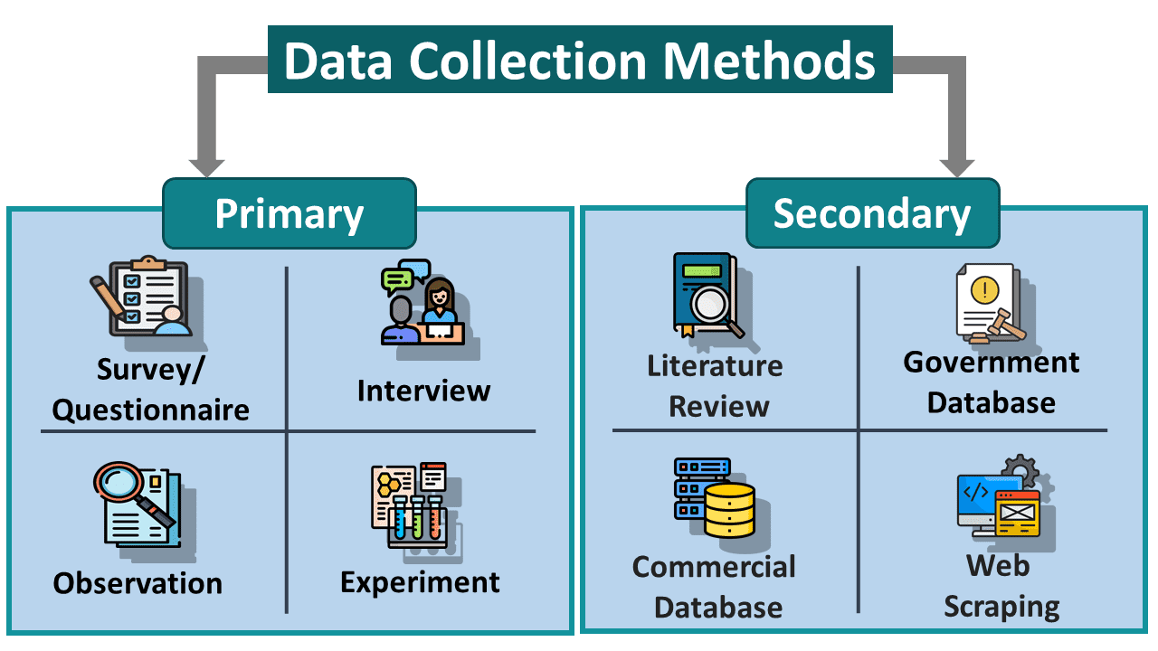

1. Primary Data Collection
Primary data collection means gathering data directly from the original source for a specific purpose.
The data is fresh, original, and collected firsthand by the researcher.

Common Methods of Primary Data Collection
1. Surveys & Questionnaires
A set of written questions used to collect information from many people.
- Can be online, paper-based, or phone-based
- Useful for collecting opinions, feedback, and preferences

Example:
A college asks students to fill out a Google Form about online learning experience.

2. Interviews
Direct conversation between researcher and participant to collect detailed information.
- Can be face-to-face, telephone, or online
- Allows deeper understanding and clarification

Example:
A company interviews customers to know why they prefer a particular product.

3. Observations
Collecting data by watching people, events, or behaviors carefully.
- Researcher records what is seen or noticed
- Useful when people may not accurately describe their behavior

Example:
A teacher observes student participation during classroom activities.

4. Experiments
Data is collected by testing under controlled conditions to study cause and effect.
- Often used in science, medicine, and psychology
- Variables are controlled and measured

Example:
A scientist tests how different amounts of fertilizer affect plant growth.

Advantages of Primary Data
- Original and accurate
- Specific to research needs
- Up-to-date information

Disadvantages of Primary Data
- Time-consuming
- Expensive
- Requires more effort and planning

2. Secondary Data Collection
Secondary data collection means using data that has already been collected by someone else for another purpose.

The data is obtained from existing sources instead of collecting it directly from people or experiments.

Common Sources of Secondary Data Collection
1. Government Reports
Data published by government agencies and departments.
- Usually reliable and large-scale
- Used for population, economy, education, health, etc.

Example:
National census reports published by the Government of Nepal.

2. Research Papers
Previously conducted studies published by researchers, universities, or organizations.
- Provides detailed analysis and findings
- Useful for literature review and academic research

Example:
Using published journal articles about climate change impacts.

3. Online Datasets
Datasets available on websites, open-data platforms, and repositories.
- Easily accessible
- Commonly used in data science and machine learning

Example:
Datasets from Kaggle or government open-data portals.

4. Company Databases
Existing organizational records and business data.
- Includes sales records, customer information, transaction history, etc.
- Helps in business analysis and decision-making

Example:
An e-commerce company analyzing past customer purchase history.

Advantages of Secondary Data
- Saves time and cost
- Easily available
- Useful for trend analysis and comparison

Disadvantages of Secondary Data
- May be outdated
- May not exactly match research needs
- Quality and accuracy may vary depending on the source

3. Automated Data Collection
Automated data collection means using technology and software tools to gather data automatically with minimal human effort.

It helps collect large amounts of data quickly, accurately, and continuously.

Common Techniques of Automated Data Collection
1. Web Scraping
The process of automatically extracting data from websites using software or scripts.
- Commonly used for collecting product prices, news, reviews, and market trends
- Tools used: Python BeautifulSoup, Scrapy, Selenium, etc.

Example:
Collecting product information from an e-commerce website like Daraz.

Reference:
Firecrawl Web Scraping Introduction for Beginners

2. APIs (Application Programming Interfaces)
APIs allow applications to communicate and exchange data automatically.
- Provides structured and reliable data
- Commonly used in web and mobile applications

Example:
Using the Weather API to fetch real-time weather information.

3. Sensors (IoT Devices)
Internet of Things (IoT) devices collect real-world data using sensors.
- Used in smart homes, healthcare, agriculture, and industries
- Data can include temperature, humidity, motion, location, etc.

Example:
A smartwatch collecting heart rate and step-count data.

4. Logs (System-Generated Data)
Computer systems and applications automatically generate logs while operating.
- Useful for monitoring, debugging, and analyzing system behavior
- Includes user activity, server access, error reports, etc.

Example:
Web server logs recording website visitor activities.

Advantages of Automated Data Collection
- Fast and efficient
- Handles large-scale data
- Reduces human errors
- Enables real-time data collection

Disadvantages of Automated Data Collection
- Requires technical knowledge
- Privacy and security concerns
- May violate website policies if scraping improperly
- System failures can affect data quality

Important Considerations
- Data accuracy
- Data privacy
- Cost of collection
- Time constraints

2.3 Data Cleaning and Handling Missing Data
Raw data is often:
- Incomplete
- Inconsistent
- Noisy

Data cleaning (also called data wrangling or munging) involves detecting and correcting errors to make data accurate and consistent. It can take 60-80% of project time.

👉 Data Cleaning = Improving data quality

Common Data Issues
- Missing values
- Duplicate records
- Incorrect data
- Outliers
- Inconsistent formats

Common Data Cleaning Tasks:
- Remove duplicate records.
- Fix inconsistent formatting (e.g., dates as "12/01/2025" vs "2025-01-12", case sensitivity in text).
- Correct structural errors (typos, invalid entries like negative age).
- Handle outliers (using IQR method, z-score, or domain knowledge).
- Standardize units and categories.

Handling Missing Data
Missing values can occur due to non-response, sensor failure, data entry errors, etc.

Methods to Handle Missing Data:
- Deletion
  - Listwise deletion (remove entire rows with any missing value) — simple but leads to data loss if missingness is high.
  - Column deletion — drop features with too many missing values (>50-70%).
- Imputation (filling missing values)
  - Mean/Median/Mode imputation (simple and fast; median better for skewed data).
  - Forward/Backward fill (for time-series data).
  - Constant value missing values are replaced with a fixed constant value (e.g., "Unknown" for categorical, 0 for numerical data).
  - Regression/KNN imputation — predict missing values using other features.
  - Multiple Imputation (advanced, creates several plausible datasets).
- Predictive Imputation
- Use ML models to predict missing values

Handling Duplicates
- Identify duplicate rows
- Remove duplicates

Handling Outliers
- Z-score method
- IQR (Interquartile Range)

Data Cleaning Steps
- Identify issues
- Handle missing data
- Remove duplicates
- Fix inconsistencies
- Validate data

Important Consideration: Understand the missing data mechanism — Missing Completely at Random (MCAR), Missing at Random (MAR), or Missing Not at Random (MNAR) — before choosing a method.

Tools: In Python — pandas functions like dropna(), fillna(), isnull(); Scikit-learn imputers.

2.4 Data Normalization and Standardization
These are feature scaling techniques applied during preprocessing to bring all features to a similar scale. Many machine learning algorithms (especially distance-based ones like KNN, SVM, Neural Networks) perform poorly when features have vastly different ranges (e.g., age in 0-100 vs salary in 0-100,000).

These are feature scaling techniques used before applying ML algorithms.

A. Data Normalization (Min-Max Scaling)
- Scales data between 0 and 1
​ $x'=\frac{x-xmin}{xmax​-xmin}$
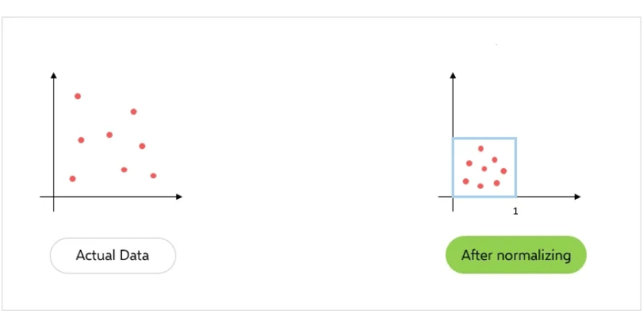
When to Use
- When data has different scales
- Used in algorithms like KNN, Neural Networks

For example, imagine you have a dataset with two features: "Room" (ranging from 1 to 6) and "Age" (ranging from 1 to 40). Without normalization, the "Age" feature would likely dominate the "Room" feature in calculations, as its values are larger. Let's take a random value from the above dataset to see how normalization works- Room= 2, Age= 30
Before Normalization:
As you can see, the scatter plot shows "Age" values spread much more expansively than "Room" values before normalization, making it difficult to find any patterns between them.
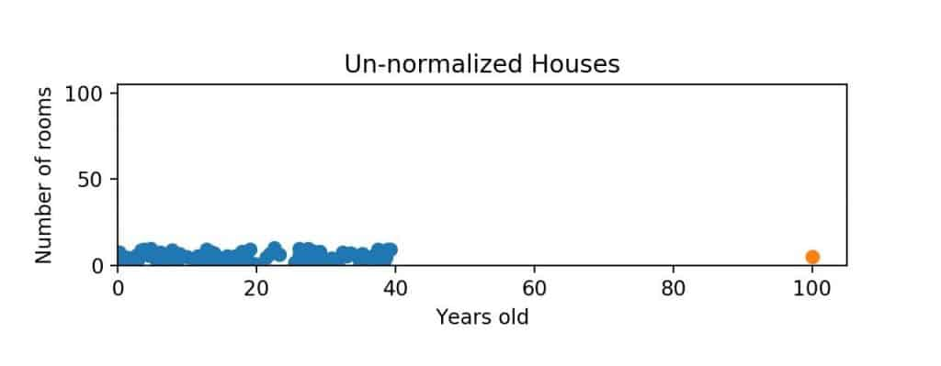
After Normalization:
Using the normalization formula X_normalized = (X - X_min) / (X_max - X_min), we get-
Room2_normalized = (2-1)/(6-1 )= 1/5 = 0.2
Age30_normalized = (30-1)/(40-1) = 29/39 = 0.74
0.2 and 0.74 are new normalized values that fall within the range of 0-1. If perform normalized on all the feature values and plotted them we will get a distribution just like the below-
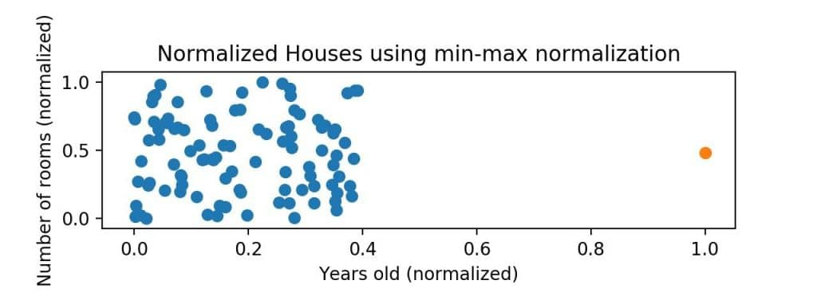
Now, this scatter plot shows "Room" and "Age" values scaled to the 0 to 1 range. This allows you to find a much clearer comparison of their relationships.

Advantages of Normalization
Normalization has various advantages that make this technique widely popular. Some of them are listed below-
- High Model Accuracy: Normalization helps algorithms make more accurate predictions by preventing features with larger scales from dominating the learning process.
- Faster Training: It can speed up the training process of models and help them converge more quickly.
- Better Handling of Outliers: It can also reduce the impact of outliers and prevent them from having an undue influence on the model.

Limitations of Normalization
Normalization surely has its advantages but it also carries some drawbacks that can affect your model performance.
- Loss of Information: Normalization can sometimes lead to a loss of information, mostly in cases where the original range or distribution of the data is meaningful or crucial for the analysis. For example, if you normalize a feature with a large range, the original scale might be lost, potentially making it harder to interpret the feature's contribution.
- Increased Computational Complexity: It adds an extra step to the data preprocessing pipeline, which can increase computational time, especially for large datasets or real-time applications.

B. Data Standardization (Z-score Scaling)
- Transforms data to have:
  - Mean = 0
  - Standard deviation = 1

​ $z=\frac{x-μ}{σ}$

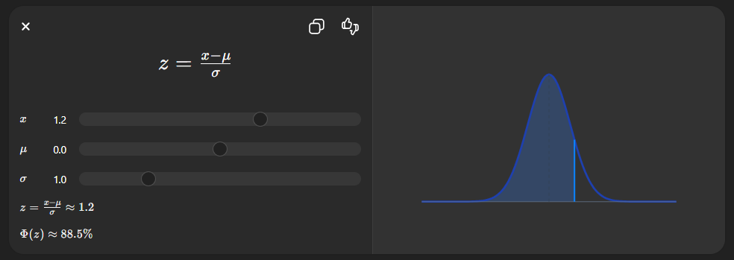

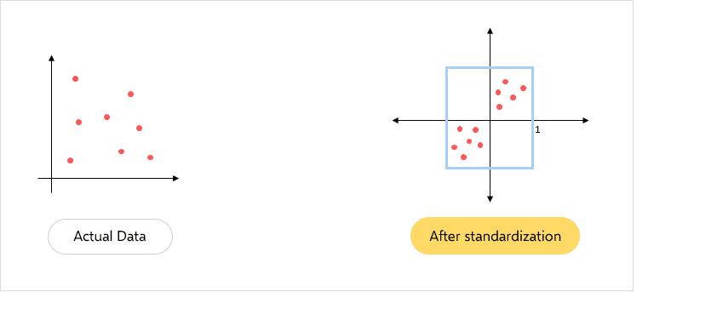

When to Use
- When data follows normal distribution
- Used in algorithms like:
  - Logistic Regression
  - SVM

For example, here is a dataset with large feature values: "Salary" (ranging from 0 to 140000) and "Age" (ranging from 0 to 60). Here, you can see that without standardization, the "Salary" feature would likely dominate the "Age" feature in calculations due to larger feature values.

To understand it clearly, let's assume a random value from the above dataset to see how standardization works-

Before standardization
Let's say a feature has values:
Salary= 100000, 115000, 123000, 133000, 140000
Age= 20, 23, 30, 38, 55

After standardization
Using formula X' = (X - Mean(X)) / Std(X)
Salary= 100000, 115000, 123000, 133000, 140000

Mean(X) = 122200
Standard Deviation Std(X) = 15642.89 (approximately)

Standardized values:
Salary X'= (100000 - 122200) / 15642.89 = -1.41
(115000 - 122200) / 15642.89 = -0.46
(123000 - 122200) / 15642.89 = 0.05
(133000 - 122200) / 15642.89 = 0.69
(140000 - 122200) / 15642.89 = 1.13

Similarly
Age X'=-0.94, -0.73, -0.22, 0.34, 1.55
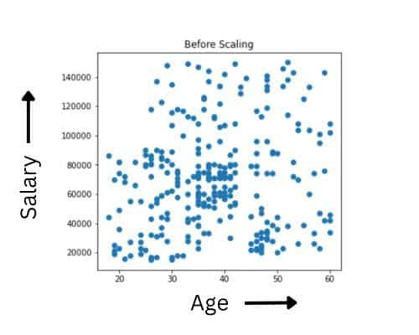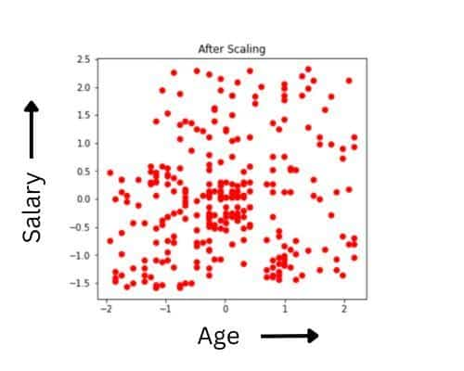
Before and after the normalization, both the plots will be the same. The only difference is in the X and Y scales. After normalization, the mean has shifted towards the origin.

Advantages of Standardization
Standardization also has its edge over other techniques in various scenarios.
- Improved Model Performance: Standardization ensures features are on the same scale, thus allowing algorithms to learn more effectively, ultimately improving the performance of ML models.
- Easier Comparison of Coefficients: It allows you a direct comparison of model coefficients, as they are no longer influenced by different scales.
- Outlier Handling: It can also help mitigate the impact of outliers, as they are less likely to dominate the model's output.

Limitations of Standardization
Standardization, while beneficial for many machine learning tasks, also has drawbacks. Some of its major drawbacks are listed below-
- Loss of Original Unit Interpretation: Standardizing data transforms values into a standardized scale (mean of 0, standard deviation of 1), which can make it difficult to interpret the data in its original context.
- Dependency on Normality Assumption: It assumes that the data follows a normal distribution. If the data is not normally distributed, applying standardization might not be appropriate for your model and could lead to misleading results.

Key Differences
Technique | Also Called | Formula | Range/Effect | Best Used For | When to Prefer
Normalization | Min-Max Scaling | ​ $x'=\frac{x-xmin}{xmax​-xmin}$ | Scales to [0, 1] (or [-1, 1] sometimes) | Distance-based algorithms (KNN, K-Means), Neural Networks | When you need bounded range; data not Gaussian
Standardization | Z-score Scaling | ​ $z=\frac{x-μ}{σ}$ | Mean = 0, Standard Deviation = 1 | Linear models, Logistic Regression, PCA, algorithms assuming normality | When data is roughly Gaussian; outliers present

Practical Flow in a Project: Raw Data → Collection → Understanding (EDA) → Cleaning (missing, duplicates, outliers) → Transformation (normalization/standardization + encoding) → Modeling.

Summary (Quick Revision)
- Data types: Structured, Semi-structured, Unstructured
- Data collection methods: Primary, Secondary, Automated
- Data cleaning fixes missing values, duplicates, and errors
- Normalization scales data (0–1), Standardization centers data (mean = 0)

Possible Exam Questions
Short Questions (2–3 Marks)
- Define structured and unstructured data.
- What is data cleaning?
- What is normalization?
- Define missing data.

Long Questions (5 Marks)
- Explain types of data with examples.
- Describe methods of data collection.
- Explain techniques for handling missing data.
- Differentiate normalization and standardization.

Practice questions:
- Consider a dataset of exam scores where the minimum score is 55 and the maximum score is 95. Using Min-Max normalization, what would be the normalized value of a score of 85 on a scale of [0,1]?
- Suppose a machine learning model requires features to be standardized using Z-score normalization. For a specific feature, the dataset has a mean of μ=120 and a standard deviation of σ=15. If a new observation has a value of x=150, what is its standardized Z-score?
- Given a small dataset of feature values X = {10,20,30,40,50} calculate the standardized Z-score for the value x=40. Round your intermediate mean and standard deviation to two decimal places if necessary.

